**Incoming SUPT Students**

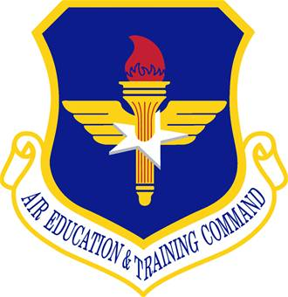 XL 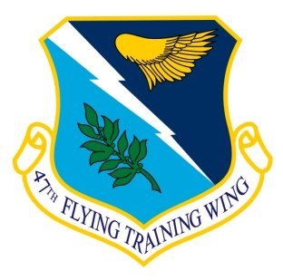

**AMERICA’S AIRPOWER STARTS HERE!**

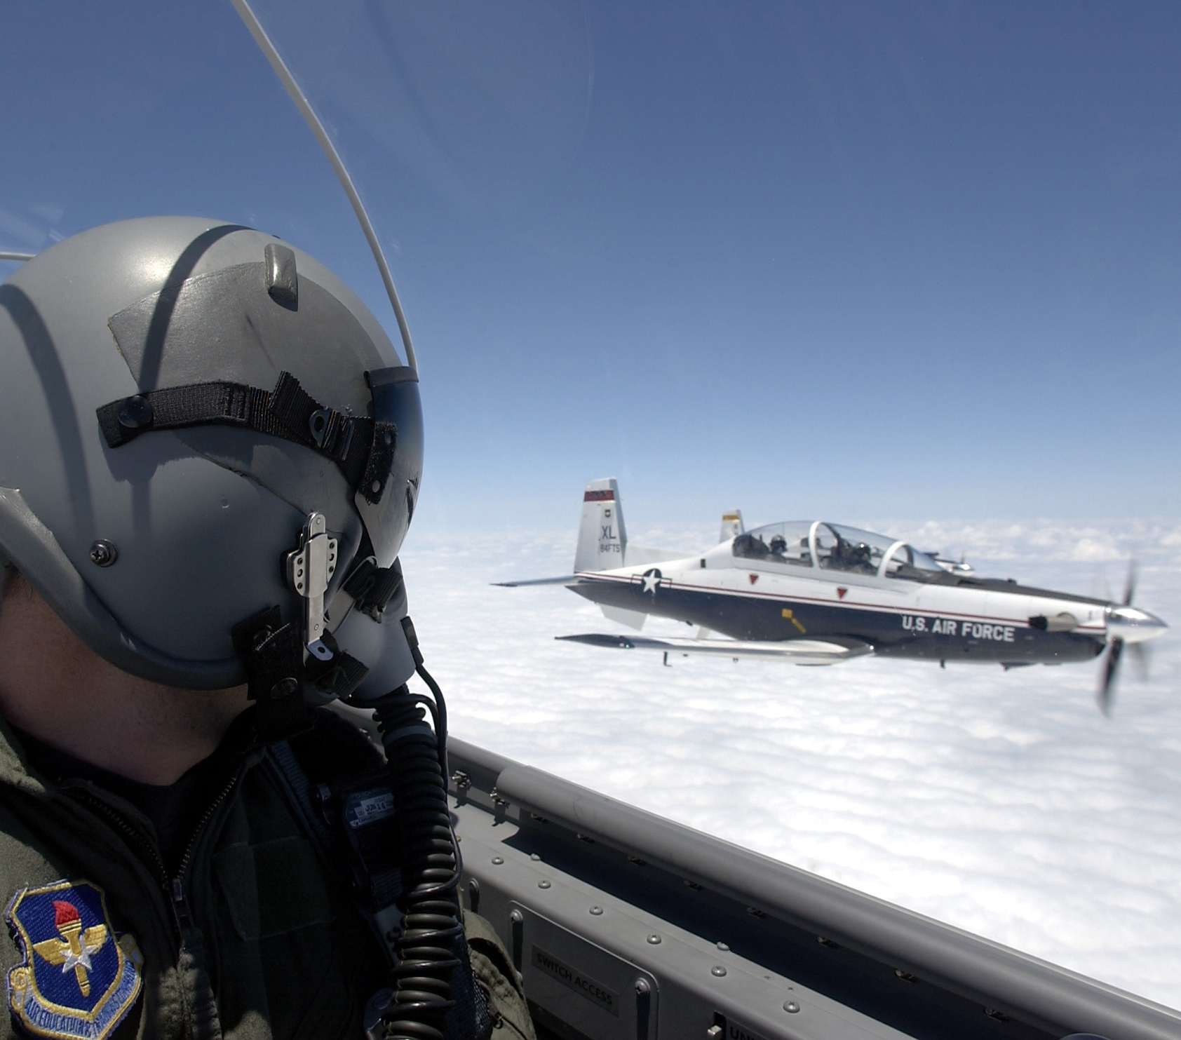

**Welcome to Laughlin AFB, TX**

**47th Flying Training Wing**

**World’s Best Flying Training Operation**

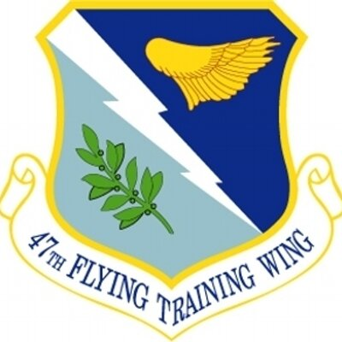

**47th FTW Mission**

Graduate the World’s Best Pilots

Deploy Mission-Ready Airmen

Develop Professional, Disciplined, Bold Leaders

***Welcome to Specialized Undergraduate Pilot Training. You can best prepare by understanding our mission, knowing how to reach us with questions, and taking full advantage of this Welcome Package we have prepared for you.***

**Table of Contents**

* **47 FTW Welcome & Mission Statement 1**
* **47 STUS/CC Welcome 3**
* **SUPT Start Dates 4**
* **What to do: One week out 5**
* **Physical** **Fitness** **6**
* **Travel Management Office 6**
* **Housing 7**
* **Traveling to Laughlin AFB 10**
* **Pets 11**
* **Weapons 12**
* **What to do: First day 13**
* **Trans Flt Location / What to Bring 14**
* **In-Processing 15**
* **Life as an APT Student 16**
* **Pass/Leave Policy 17**
* **Notes on Officership 18**
* **Common Problems 19**
* **Base Facilities / Numbers 20**
* **DA-20 Boldface / Ops Limits 21**
* **Laughlin Experience 23**
* **Post SUPT 24**

# 

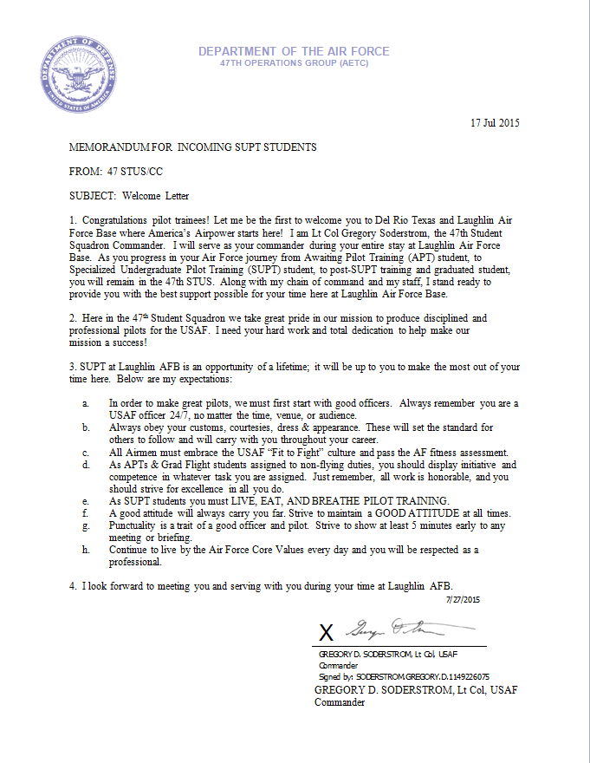

# **SUPT Class Start Dates:**

|  |  |  |
| --- | --- | --- |
| **Class** | **Pre-Flying Academic Start** | **Projected Graduation** |
| 17-01 | 02 Oct 15 | 21 Oct 16 |
| 17-02 | 28 Oct 15 | 17 Nov 16 |
| 17-03 | 24 Nov 15 | 13 Dec 16 |
| 17-04 | 22 Dec 15 | 18 Jan 17 |
| 17-05 | 27 Jan 16 | 09 Feb 17 |
| 17-06 | 19 Feb 16 | 08 Mar 17 |
| 17-07 | 14 Mar 16 | 31 Mar 17 |
| 17-08 | 05 Apr 16 | 24 Apr 17 |
| 17-09 | 26 Apr 16 | 16 May 17 |
| 17-10 | 18 May 16 | 07 Jun 17 |
| 17-11 | 09 Jun 16 | 29 Jun 17 |
| 17-12 | 30 Jun 16 | 21 Jul 17 |
| 17-13 | 25 Jul 16 | 11 Aug 17 |
| 17-14 | 16 Aug 16 | 05 Sep 17 |
| 17-15 | 09 Sep 16 | 27 Sep 17 |

***If you have any questions regarding how early you are allowed to report to Laughlin AFB for SUPT training, please call the transition office front desk at:***

**DSN 732-5211 / COMM (830) 298-5211**

**What to do: On****e week out**

* You may call the Laughlin Manor (VOQ) up to 90 days prior to reserve a room for your first couple of nights here. You may stay at the Laughlin Manor up to 30 days. The Air Force will reimburse you for the first 10 days, but you will have to use BAH to pay over ten days. Remember, you must pay for your room every 15 days.

Laughlin Manor: DSN: 732-5731; Commercial: (830) 298-5731

* Get an Official Mail Center (OMC) Box Number to forward mail or use the General Delivery address. This is optional. You will be required to do this during in processing if you are significantly delayed from getting a permanent address.

PSC Box Duty Phone: DSN 732-4310; Commercial (830) 298-4310

General Delivery Address:

(Ensure you check in to the OMC if you will have mail delivered to the address below)

Name

General Delivery

477 4th St. Suite 1

Laughlin AFB, TX 78843-5144

* Call ahead to the Transition Flight if you have specific questions about the base. **The Transition Flight is the office that you will be reporting into the first day.**

**Transition Flight: DSN: 732-5211; Commercial: (830) 298-5211**

* If you have a pet or weapons, please see the students with pets and or students with weapons pages.
* Prepare for the Air Force Physical Fitness test as you may be required to take it soon after your arrival at Laughlin AFB.

**Physical Fitn****ess**

If you are not involved in a fitness program, we recommend you start one before your arrival. During your first month of training, you will take a physical fitness test and strength fitness test. You can best prepare for these tests with a combined weight and aerobic training program.

The Air Force Physical Fitness Testwill be administered during the first month of SUPT in accordance with Air Force instruction 10-248. Students that fail to meet the fitness standard (75 or above) will be entered into a conditioning program and retested. The AETC/DO directs that all UPT students not meeting physical fitness standards will be removed from training and reclassified. The test consists of a 1.5 mile run, a waist measurement, push-ups and sit-ups.

**The max weight to start UPT is 245lbs**

**T****ravel Management Office**

On behalf of the 47th Transportation Division, welcome to Laughlin Air Force Base (AFB). The TMO provides transportation including travel arrangements for members/dependents, and household goods transportation & storage. As the military member, you provide the dates and TMO makes the arrangements for passenger travel and packing, pick-up and shipment of personal property.

Two problems UPT students experience while getting settled-in at Laughlin AFB are:

* Property does not arrive in time, or prior to your class start date.
* Not having enough time after your training starts to arrange for storage of excess property.

**Before you make the move to Laughlin AFB, review these helpful tips.**

* Contact TMO as soon as you arrive on base. Our number is (830) 298-5388 or 5178. We will ask for your name and a telephone number where you can be reached. When property arrives, we have two hours to arrange for delivery. If we cannot contact you, the property will be placed in storage. If your property goes into storage, it may take a few days to coordinate a scheduled delivery to your residence.
* **Only ship items that are absolutely necessary. Single members living in the dormitories do not need to bring furniture**. Prior to your personal property shipment, single and unaccompanied members should contact the housing office at (830) 298- 5733 to determine how dormitories are furnished. Housing will only pay for storage if you live on base. The bottom line, only bring what you need.
* For married or accompanied members, having a spouse to assist with your move is beneficial. For some the time available during in-processing, prior to your training start date is very limited. Include your spouse in all facets of the move.
* Frequently asked questions include, "can I have my personal property delivered on the weekend." The Government does not pay overtime costs associated with weekend deliveries. Due to this fact, local moving agents do not deliver on weekends. Please keep this in mind when scheduling a time for your delivery. Local agents understand that your schedule is tight and will do everything within their power to accommodate your needs. Department of Defense regulations state, "Commanders will provide time to all personnel for the shipping and receiving of personal property."
* It is important that personal property shipments are shipped at least three weeks prior to your scheduled arrival, ensuring the availability of your property once quarters are assigned. Remember, if your property goes into storage, it may take a few days to coordinate a scheduled delivery to your residence.
* Only 90 days of temporary storage is authorized (with or without dependents). The 90 day limit begins once property arrives at Laughlin AFB and is placed in storage.
* If you can arrange for quarters prior to your move, ask TMO about a "direct delivery." Your property will be delivered directly to the address you provide. Keep in mind, you must be here to receive your property.
* If delivery of your goods becomes an issue, it may be possible to have someone assigned to the Transition Flight sign for your personal goods.
* For further information about the Laughlin AFB TMO or other transportation functions, please call us at (830) 298-5388.

Don't hesitate to ask for assistance from the professionals we have working for us.

//SIGNED// //SIGNED//

Traffic Management Officer Chief, 47th Transportation Division

**Housi****ng**

**UNACCOMPANIED/SINGLE MEMBERS**

You will either stay in a single occupancy dorm room or, upon availability, share a government owned duplex house with another student. Exception to this policy will be on a case-by-case base, however do not expect to live off base. Unaccompanied/single members are not authorized to contact Laughlin Family Housing without specific prior authorization from the Housing Office.

The Dormitories include:

* 1 large bedroom that includes an extra long full size bed, chest of drawers, TV media chest, and desk and chair.
* 1 kitchen with stove, refrigerator, and microwave
* 1 private bathroom
* Every room is cable and phone ready, please make arrangements with the following companies for service (optional):
  + Cable: Time Warner (830) 775-3567
  + Phone: Verizon (800) 483-4000
* The laundry facilities are centrally located within the UOQ building and the service is free
* Wait time for a dormitory room averages from 1 day to 6 weeks (these times are an average and vary from class to class)

The Government Duplexes (located on Ciarfeo and Carlson) include:

* 2 Bedrooms
* 1 Bath
* 1 Full Kitchen with microwave, stove, refrigerator, and dishwasher. Each unit has hookups for a washer and dryer.
* Wait times on average from 1 day to 6 weeks for unaccompanied/single students (these times are an average and can change from class to class).
* Roommates must be within one class from each other.

**MARRIED MEMBERS**

Married members have the option to buy or rent off base or to rent on base from Laughlin Family Housing. Married members who are on accompanied orders but will be unaccompanied while in UPT please contact the Trans Flt office.

Laughlin Family Privatized Housing managed by Hunt Military Communities (830) 298-1701:

* Rent is equal to your BAH, utilities included – rent is paid in advance
* Free yard care
* No pet or security deposit
* Free pest control
* 2, 3, and 4 Bedroom houses available
* Fences in some yards
* Resident appreciation events
* Appliances included: gas stove, refrigerator, dishwasher, some microwaves

**MORE INFORMATION**

* BAH rates can be found here: [Laughlin AFB BAH](http://www.defensetravel.dod.mil/perdiem/bah.html) Zip code is: 78843/78840
* Electricity: (888) 216-3523
* More information on Laughlin AFB and Del Rio Housing can be found at the [AF cross roads website](http://www.afcrossroads.com/dodinstall/baseindex.cfm?base=base&logo_ID=1&ServiceName=U.S.+Air+Force&choseBase=new&site_ID=4465&x=17&y=19)
* Military Housing Office: (830) 298-5650



**T****ravel to Laughlin AFB**

1. San Antonio International Airport is usually the most economical route to use for travel by air though there are several other options at various distances of travel. As of April 2013 there is no commercial air service into Del Rio International.
2. If you are traveling by automobile from the east (San Antonio), take Highway 90 west to Del Rio. Laughlin AFB is located on Hwy 90 approximately 6 miles east of Del Rio. From the west (El Paso), you may travel on Interstate Highway 10 east to Van Horn and then follow Hwy 90 east to Del Rio. You may also elect to remain on IH 10 east to Sonora and then Hwy 277 south to Del Rio (longer route but more time spent on the Interstate, if you prefer). Once in Del Rio follow the signs to Highway 90 east. This will take you directly to Laughlin AFB.
3. The main gate is located approximately 5 miles east of Del Rio on Highway 90.  The main gate is open 24 hours.  The west gate is located 7 miles south of Del Rio on Highway 277.  The west gate's hours of operation are M-F 0600-0900 and 1430-1730.  The west gate is closed on the weekend and holidays.

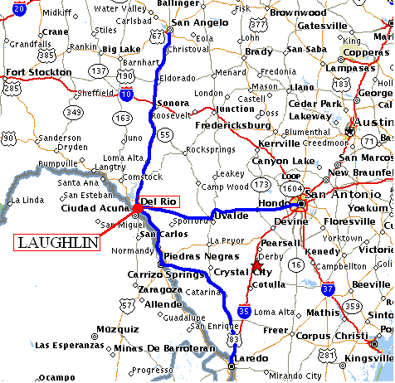

**Students with P****ets**

MEMORANDUM FOR INCOMING SUPT STUDENTS

FROM: 47 STUS/DOT

SUBJECT: Students with pets

1. Congratulations on your assignment to Laughlin AFB and Specialized Undergraduate Pilot Training. In order to comply with AFI 32-6005 and AFI 32-6004 each base Wing Commander is responsible for creating the policies for the housing units for his base.

2. For Laughlin AFB, the only pets allowed in billeting, TLFs, unaccompanied officer duplexes or the dorms are domesticated fish. If a student comes to pilot training with anything other than a fish, they will be responsible for making arrangements for the boarding of their pets for the duration of their stay. According to AF instructions, all unaccompanied students are required to live in the dormitories or duplexes. Married students may have pets in privatized housing but there are limits on the number and breed restrictions (contact housing for exact rules).

3. If you arrive at pilot training with a pet there are a few options available to you. You can arrange to leave your pet with someone residing in married housing or off-base, you can leave your pet with a family member, you can put your pet in a kennel, or you can reside off base **with a waiver**. *However,* *WAIVERS AUTHORIZING STUDENTS TO LIVE OFF BASE ARE GRANTED BASED PRIMARILY UPON UOQ AVAILABILITY,* ***NOT*** *UPON PET OWNERSHIP.* The kennels available in town are: [Animal House](http://www.animalhouse.thekennel.com/) (830-768-1105) and The Pet Resort (830-298-1345).

//Signed//

Transition Flight Commander

47th Student Squadron

**Students with W****eapons**

MEMORANDUM FOR INCOMING SUPT STUDENTS

FROM: 47 STUS/DOT

SUBJECT: Students with Weapons

1. In an effort to ensure the highest level of security for our students as well as those already assigned to this installation, weapons and ammunition are not allowed to be stored in billeting, the Temporary Living Facilities, or the dormitories. Weapons must be stored in the Security Forces Armory or secured with a trusted member in an off base property or base housing. Unaccompanied officer duplexes are NOT considered base housing and weapons will not be stored there. If it is necessary to store the weapons in the armory, contact Security Forces at commercial (830) 298-5100 or DSN 732-5100 upon arriving at the base. The Security Forces Armory is available 24 hours a day. Please ensure all weapons and ammunition are secured appropriately before checking into billeting.

//Signed//

Transition Flight Commander

47th Student Squadron

**What to do: Fir****st day**

* Check-in at Laughlin Manor (VOQ) for temporary lodging.

Laughlin Manor: DSN: 732-5731; Commercial: (830) 298-5731

* When you drive onto the base from the main gate (off Highway 90), continue straight on Liberty Drive until you intersect Arnold Blvd. Take a right on Arnold Blvd and proceed for one block to Fourth Street. Laughlin Manor will be the large building with palm trees on your left across the street from the BX.

* Report to the Transition Flight (Bldg. 320 room A133) at 0830 Monday through Friday for further in-processing instructions. Uniform is ABUs. Here you will receive an in-processing checklist and instructions on what to do next. See pg. 15.

***All incoming students will be assigned to the Transition Flight until their respective Pre-Flying Academics class start date.***

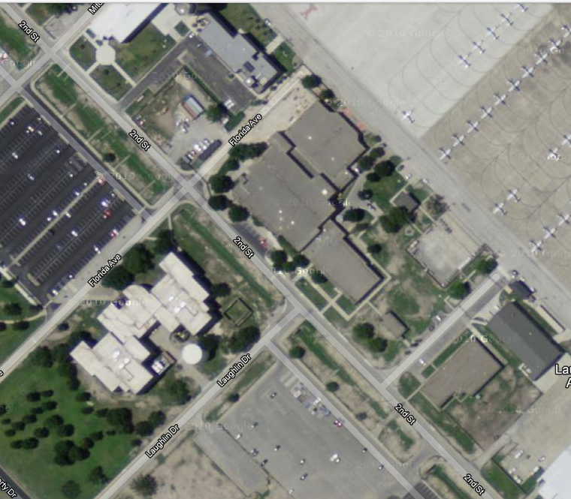

**Transition Office:** Bldg. 320 Ramp on side of bldg. Double doors on ramp, Office straight across door.

**What to bri****ng**

Have the following items readily accessible for in-processing to ensure a smooth transition during the first few days:

1. 20 copies of orders (Front and Back)

2. Identification Card (Drivers license and military ID card if you have one)

3. Most recent official Physical Fitness Test scores

**Note**: **You will likely be required to take another PFA shortly after arrival.**

4. Proof of car registration, insurance, and title

5. Medical, shot, and dental records (Flight Physical)

6. Traffic Management Office papers and receipts from move if applicable

7. All uniform items (Flight suits will be issued prior to Introductory Flight Screening (IFS))

8. All personnel records

**In-Processing**

1. During your initial briefing with the SDOs, you will be given a schedule with a series of appointments as well as an in-processing checklist. Do not attempt to accomplish checklist items that require appointments outside of your assigned time. **It is imperative that you are on time to every appointment, as any missed appointments will greatly delay in-processing.**
2. Between appointments, begin completing the forms included in your in-processing packet. (You will be given an address during your appointment with the post office.)
3. For the High Risk Activity Form, list any hazardous activity you may ever do while at Laughlin. Regardless of past experience, we require listing Boating/Water Skiing as a hazardous activity as that is a very popular activity around Laughlin. The Transition Flight Commander will review this form with you once completed.
4. You will have several computer based training (CBT) programs in addition to online checklist items. Once you have gained computer access (check your in-processing schedule) you should work on accomplishing this training between appointments. Computers are available in the back room of the student squadron (STUS). You can access the ADLS website via the Air Force Portal.
5. Motorcycle riders are required to meet with the motorcycle safety rep **prior** to riding a motorcycle on base.
6. If you are planning to leave the local area (30 miles radius) you must turn in a **Form 29B** to the SDO inbox and receive a safety briefing by the Assistant FLT/CC or FLT/CC. Weekend Passes and Leave will be discussed in greater detail later in this booklet.

**Life as an APT**

**Responsibilities**

Until you begin SUPT, you will be known as an APT (Awaiting Pilot Training) student. Your first responsibility as an APT is to complete in-processing. Your checklists provided by the Transition office will help you greatly in accomplishing this task. Since you will be employed throughout the 47 FTW shortly, it is imperative to complete your in-processing checklist ASAP.

**Accountability**

Every day you will be required to report to the transition office at 0800 or to your job at the time directed by your supervisor. UOD for in-processing is ABUs, or as required for your APT job. On Wednesday at 0900, all APTs (regardless of job) will report to Anderson Hall in building 320 for weekly Roll Call. Roll Call is the Flight Commander’s opportunity to pass along critical information to all APTs as well as receive feedback. Failure to attend either daily or weekly roll call may result in adverse administrative actions.

**SDOs**

Within the transition office you will find several APTs known as SDOs (Staff Duty Officers) working various projects for the Flt/CC and Assistant Flt/CC. These Lieutenants will be your first stop for any transition office related issues or questions, and are a great resource for more information.

**Passes / Leave Policies**

**Weekends:** Be aware that time off on weekends are not a given when you are an APT. If you are not assigned a job, the transition office will utilize you, and this may include weekends. The SDOs will give as much notice as possible in order to not interrupt any plans. When making plans for the weekend it is important to fill out a **29B**. All APTs planning on traveling beyond **30 miles** of Laughlin AFB must fill out a 29B and attend a safety briefing led by the Transition Flight/CC. Any High Risk activities will also need to be briefed by the Flight Commander. There are several weekend activities within the local area including the AF marina on Lake Amistad and countless bike and hiking trails in the local parks as well as on base. The O-Club also offers a safe environment on Friday and Saturday nights.

**Passes:** Passes are days which you are not required to work. Every weekend is considered a two day pass unless specifically assigned duties on either of those days. Additional passes are typically given over holidays.

**Leave:** Each active duty member of the USAF receive 2.5 days of leave per month. Leave begins at 1201 on the day before your first official day of charged leave to allow for travel. You must submit a Leave Checklist in conjunction with a 29B before your leave will be approved on Leave Web.

**Limitations:** APTs are allowed to travel anywhere in the lower 48 states on a pass if the 29B has been approved.

**International/OCONUS Travel:** International travel must receive approval from the 47 STUS/CC. This process is long and requires an extensive paper trail. **No one is allowed to enter Mexico within 50 miles of the Mexican border and the Mexican states of Coahuila, Chihuahua, Durango, Jalisco, Michoacan, Nuevo Leon, San Luis Potosi, Sinaloa, Tamaulipas, and Zacatecas are also off limits**

**Leave vs. Pass:**

IAW AFI 36-3003 leave CANNOT be combined with a pass. One common occurrence is over the winter holidays. Say for example you want to head home for 20 Dec through 27 Dec. If a 2-day pass is given for 24-25 Dec, you will still be required to take leave over the **entire** period. (You must use 8 days of leave, rather than try to combine 6 leave days with a 2-day pass)

**Negative Leave:**

For those who have a legitimate and substantive need to use more leave than they have accrued, there is the option to use negative leave. Such requests must be submitted via hardcopy and will be approved by the 47 STUS/CC on a case-by-case basis.

**Notes on Officership**

**Uniform Wear** – As an officer in the U.S. Air Force, your dress and appearance should never be brought into question. Any deviations from regulations will be dealt with swiftly and severely. UOD as an APT is ABU’s unless otherwise directed. You will not wear a flight suit at Laughlin until authorized by your Class Commander in SUPT.

**Core Values** – The USAF Core Values must be present in every aspect of your lives including off duty time. You are an AF officer 24/7. Every day you will experience situations in which your attitude and integrity will be tested. Your response to these situations will eventually turn into habits. Start becoming the officer that you have envisioned yourself to be.

**Alcohol** – If you consume alcohol, you must know when to stop. You know you have crossed the line with alcohol when you can no longer control your actions. Be aware that the repercussions for alcohol related incidents are extremely severe. Any alcohol related incident is grounds for removal from SUPT, and possibly the USAF. A DUI will result in a LOR/UIF, removal from SUPT, likely separation from the Air Force, and educational recoupment of all scholarships awarded. (For USAFA graduates, that number tops $100,000) Don’t trade the chance to pilot a multimillion-dollar aircraft for another three-dollar beer.

**The Wingman Policy** – We take care of each other. This isn’t just being a DD, although that is a part of it. Be the voice of reason in a sticky situation and never leave a buddy behind. **A good wingman will not only have a plan, but will carry out that plan or get the plan back on the right track when things go wrong.**

**Common Problems Experienced by APT Students**

**Housing:** Pending your time of arrival at Laughlin Air Force Base you may need to spend more than 30 days at billeting due to overcrowding. This is often the case for lieutenants arriving from USAFA in August or ROTC Detachments in autumn. Be patient as housing is doing their best to accommodate everyone.

**Firearms:** There is limited space available within the armory for your firearms. It is highly recommended that you contact the base armory prior to your arrival at Laughlin AFB to ensure there is room for your weapon(s). Although it is easy to obtain a hunting license in the state of Texas, unless it absolutely needed, it is suggested that you leave your firearms at your home of record.

**Pets:** Hunt cannot guarantee you a house with a fenced yard. Contact Pinnacle prior to your arrival.

**Finance:** Sometimes due to unforeseen and/or uncontrollable circumstances, pay may be delayed up to 30 days. Make sure that when you arrive at Laughlin AFB, you have the ability to financially support yourself during this time period. There is the possibility of receiving a pay advance if necessary but this option is limited to a case-by-case basis.

**In-Processing:** This process may seem redundant and often times with slow results. Please understand that each program requires time to build a package. Go to the SDOs with any question or concerns.

**B****ase Facilities**

**Hours Phone**

**Laughlin Manor (VOQ)** 24/75731

**Transition Flight** M-F 0800-16305211

**UOQ** M-F 0730-16305903

**TMO** M-F 0730-16305206 or 5178

**Security Forces** M-F 0900-16005100

**\* For the Armory, call the above extension at all hours**

**Official Mail Center (OMC)** M-F 1100-17004310 or 5264

**Fitness Center** M-Th 0500-2300 5251 or 5326

F 0500-2100

Sat-Sun 0700-1900

**BX** M-Sat 0900-1900 2111

Sun Closed

**Commissary**  Mon Closed 5822

T-Th 1000-2000

W&F 0800-1800

Sat 0900-1800

Sun 1000-1700

**Subway (BX)** M-Sat 0900-1900 2600

Sun Closed

**Rio Grounds (BX)** M-F 0700-1430 422-2071

**Stripes**  M-Th 1100-1400 5295

F 1400-2200

**Silver Wings (Flt Line)** M-F 0700-1600 5661

**Club XL** M-F 1100-1300 5134 or 5374

***Laughlin AFB does not have a Military Dining Facility***

DSN 732-**XXXX** COMM (830) 298-**XXX**

**Bo****ld Face and Ops Limits**

During Introductory Flight Training (IFT) you will be required to write and recite the following information verbatim. Visit DossIFS.com for more information.



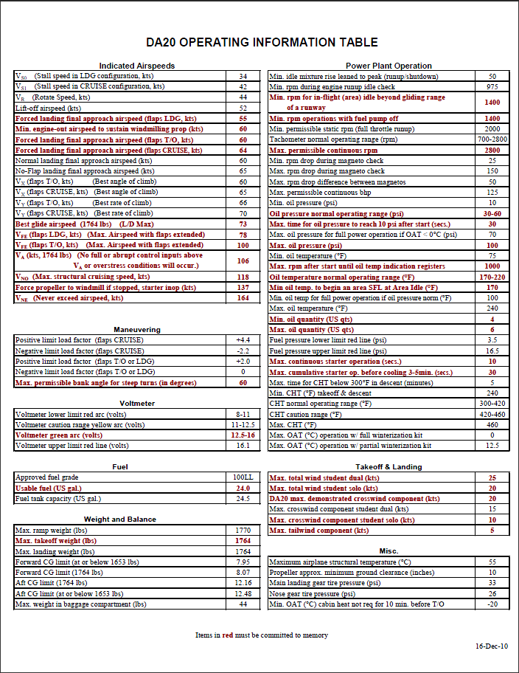

**The Laughlin Experience**

The following is an overview of the training you will receive at Laughlin AFB. As stated earlier, during your entire tour at Laughlin, you will be under the command of the 47 STUS/CC.

**I. APT—The time before SUPT starts**

* Assigned to 47 STUS/DOT with the Transition Flight Commander as your supervisor, regardless of additional job throughout the wing.
* Initial Flight Training (IFT) in Pueblo, CO. TDY assignment for 3-6 weeks. Here you will fly the DA-20 in an SUPT style format. This is a screening program designed to see whether you are capable of completing SUPT. Ask other APTs for assistance and advice so you can hit the ground running. Once again, you are still under authority of Transition Flight for any non-IFS issue.

**II. SUPT Pre-Flying Academic Phase (Phase I)**

* On Day 1, you will be assigned a 47 STUS Phase I Flight Commander. The Flt/CC is your link to the 47 STUS chain of command and will support you throughout Phase I.
* Pre-flying academics is a 31 day academic program focusing on aerospace physiology, aircraft systems and SUPT basic building blocks.

**III. SUPT Primary Phase (Phase II)**

* As you transition to the Primary Phase, you will have a STUS Class Commander. You will be assigned to a Flying Training Squadron Flight Commander in charge of managing your syllabus training. Your STUS Class/CC will handle all other issues.
* Phase II is your introduction to the flightline in SUPT. The objective of Phase II is to prepare graduates for the advanced phase and future responsibilities as military officers and leaders.
* Phase II is a 90 day flight training program during which the student receives 50 hours of simulator training and 87 hours flight time in the T-6. Students receive simulator training in Basic, Contact, Instruments, Formation, IFR/VFR, and Low Level flight. There are four formal check rides: Mid-phase, Final Contact, Instrument, and Formation.

**III. Track Selection**

* Personal preference and final merit rank after the Primary Phase determine which track you will continue on in Advanced Phase. Merit rank is 40% check ride performance T-Score, 30% daily maneuver T-Score, 10% academic T-score, and 20% FLT/CC ranking T-Score.
* There are three tracks: T-38s, T-1s (both at Laughlin), and UH-60 (Fort Rucker, AL).

**IV. Advanced Phase (Phase III)**

* This is the advanced phase of SUPT during which your flying abilities continue to be challenged in each airframe. T-38s receive 30 hours of simulator training, and 90 hours of flight time. T-1s will receive 44 hours of simulator time and 87 hours of flight time.

Post SUPT

* **Water Survival** — This is a 3-day course in Pensacola, FL. The course is designed to teach the basic of survival in a maritime environment, including fishing and raft building. The first day is academics and the last two days are application.
* **Introduction to Fighter Fundamentals**— If selected for a fighter after completing the Advanced Phase, IFF is your next stop. IFF is designed to teach the basic theory and application of flying fighter type aircraft. IFF students train in the T-38 to become proficient in air-to-air and air-to-ground tactics as appropriate to their assigned aircraft.
* **FAIP**—If selected as a First Assignment Instructor Pilot (FAIP) you are assigned to a T-6, T-1, or T-38. Your next stop will be Pilot Instructor Training (PIT) at Randolph AFB, TX for the 4-month course. After PIT you will return to Laughlin AFB for a 3-4 year assignment as an instructor followed by an MWS assignment.
* **FTU**—Those assigned to an MWS will depart Laughlin AFB for their respective Formal Training Unit course (FTU). Each FTU is unique to that MWS with course lengths ranging from 5 months to 9 months. Operational Assignments follow graduation from FTU.

F-22—Tyndall AFB, FL

F-15C—Kingsley Field, OR

F-15E—Seymour Johnson AFB, NC

F-16—Luke AFB, AZ

A-10—Davis-Monthan AFB, AZ

B-1—Dyess AFB, TX

B-2—Whiteman AFB, MO

B-52—Barksdale AFB, LA

C-17—Altus AFB, OK

C-5—Lackland AFB, TX

C-21—Keesler AFB, MS

C-130—Little Rock AFB, AR

HH-60—Kirtland AFB, NM

KC-135—Altus AFB, OK

KC-10—McGuire AFB, NJ

RC-135—Offutt AFB, NB

RPA—Creech AFB, NV